TERRAFORM TASK – 01
- Install Terraform on your PC
- Note down below points, Terraform Init Terraform Plan Terraform Apply Terraform Provider.
- Integrate a sample Terraform template in Jenkins.
- Open a web browser.
- Go to the official Terraform website: download terraform
- This page contains Terraform installation options for different operating systems
- From the left menu, select Windows.
- Under Binary download, choose AMD64 (for 64-bit Windows systems).
- Click on Download to download the Terraform ZIP file.
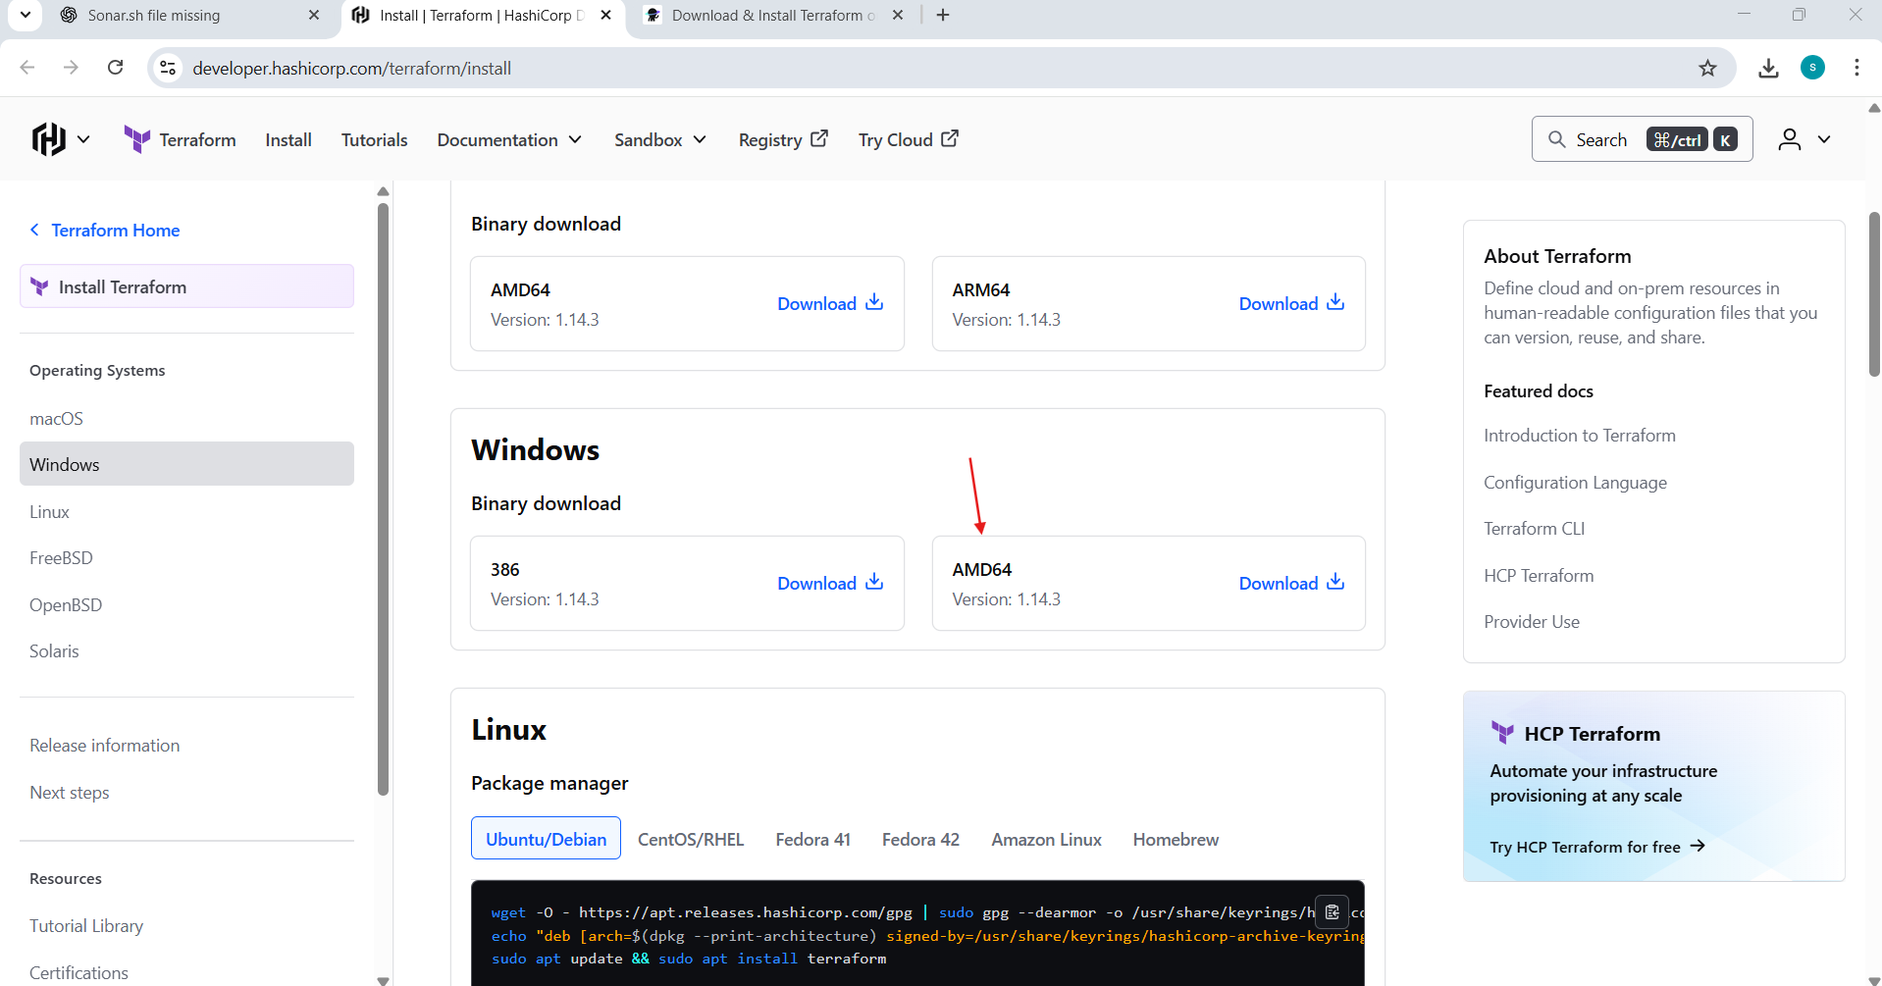

Terraform has been downloaded
- The “Extract Compressed (Zipped) Folders” window opens.
- Click on Browse to choose a custom extraction location
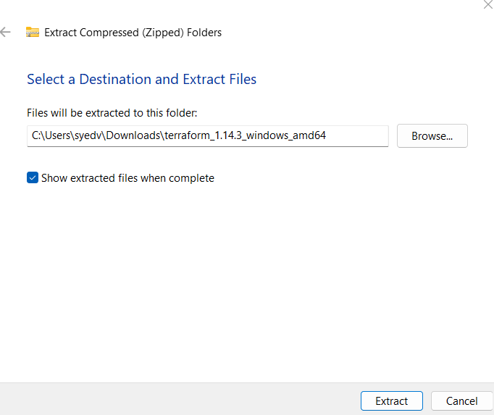

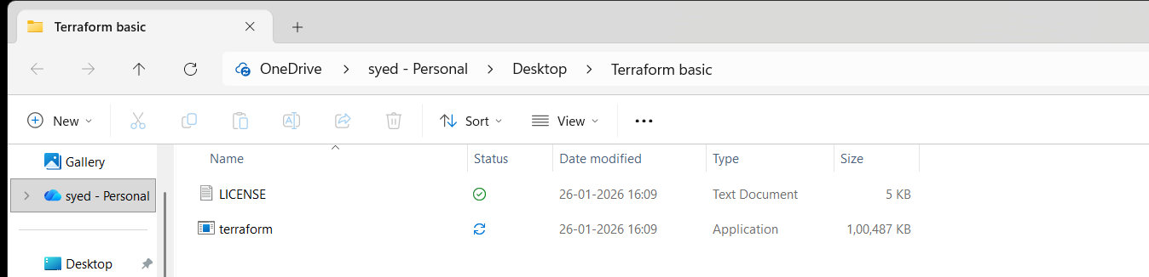
Click "Edit the system environment variables"
Click Environment Variables
Under System variables, find Path
Click Edit → New
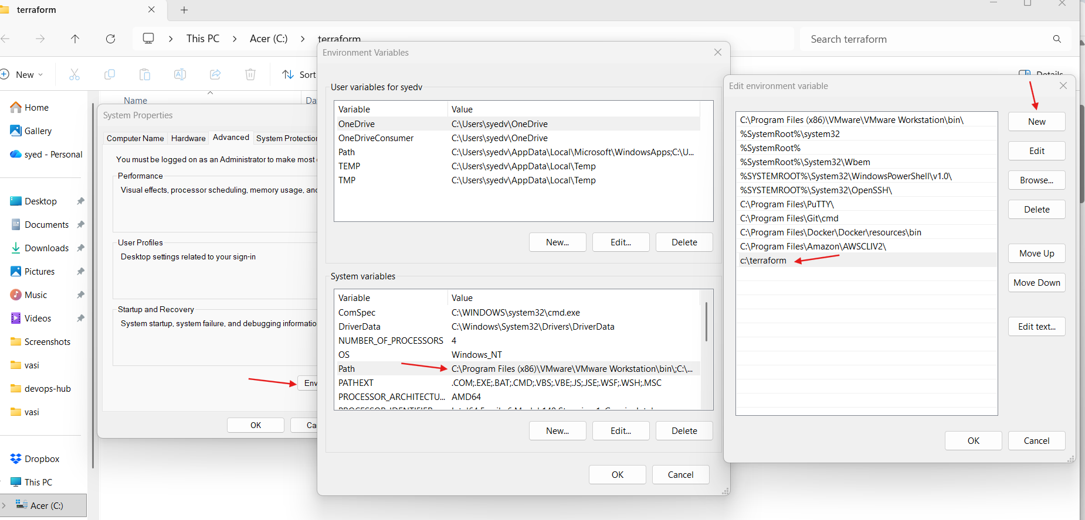
- Install the hashicop terraform
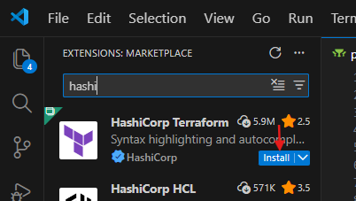

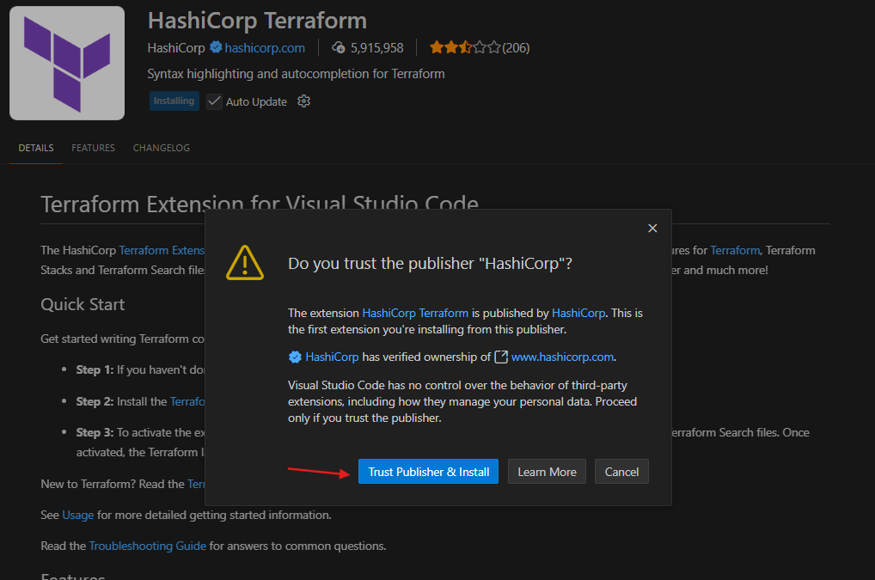
- Successfully installed

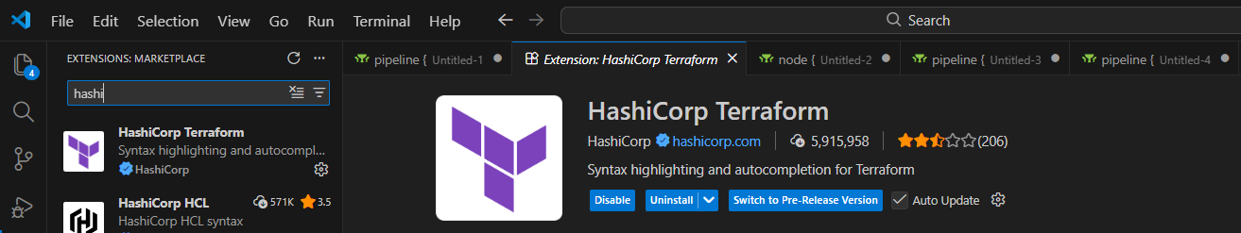
- Open VS Code → Explorer
- Click Open Folder
- Select your Terraform project folder
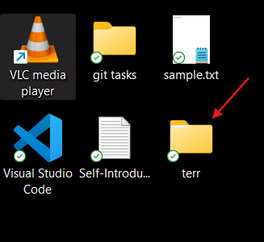
- Terraform folder is added in vs code

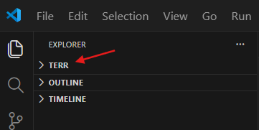
- Inside the opened folder, click New File.
- Create a file named main.tf.
- This file will be used to write Terraform configuration code
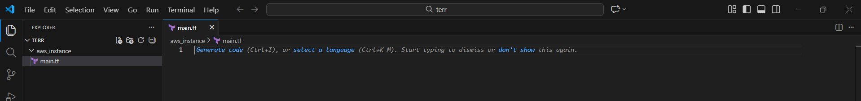
- Open main.tf in VS Code
- Write the Terraform local_file resource
- Set resource name and filename
- Save the file (Ctrl + S)

- Check the version of terraform
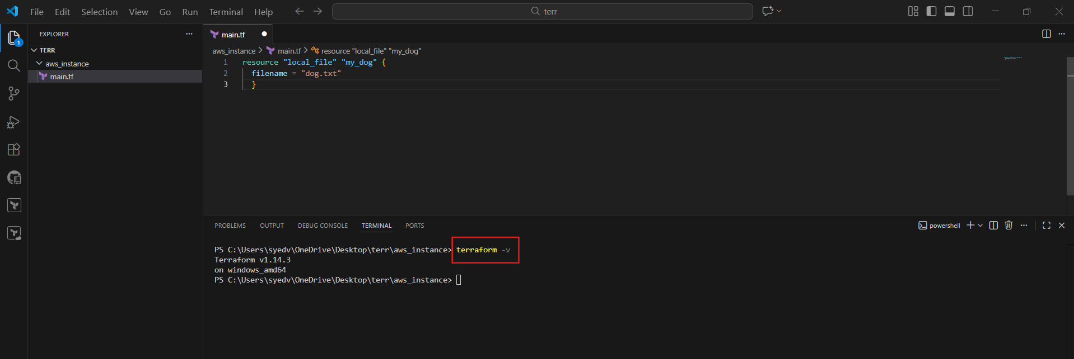
- Open VS Code terminal
- Go to Terraform project folder
- Run terraform init
- Providers are downloaded
- terraform.lock.hcl file is created
- Initialization completes successfully
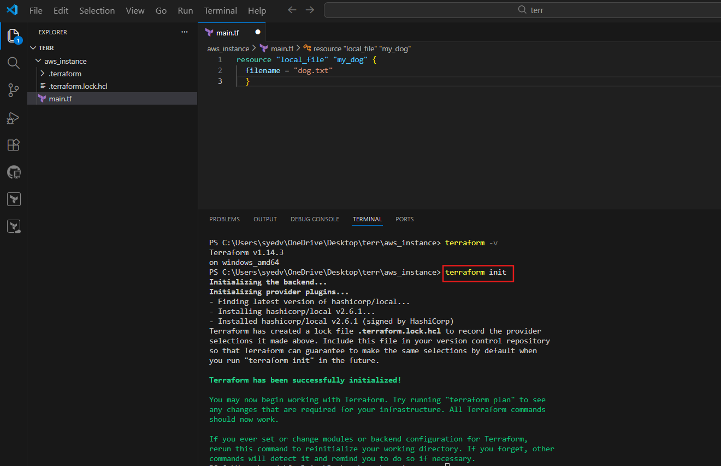
- Update main.tf to include file content.
- Run the command:
- terraform apply
- Terraform displays the execution plan.
- Type yes to approve the changes.
- Terraform creates the file and updates the state file
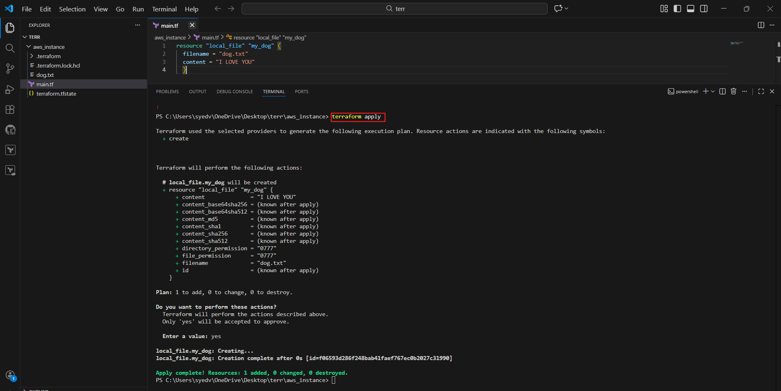
Run:
terraform apply
- Terraform plans to destroy the old resource and create a new one.
- Confirm by typing yes.
- Local file resource is destroyed.
Random pet resource is created successfully

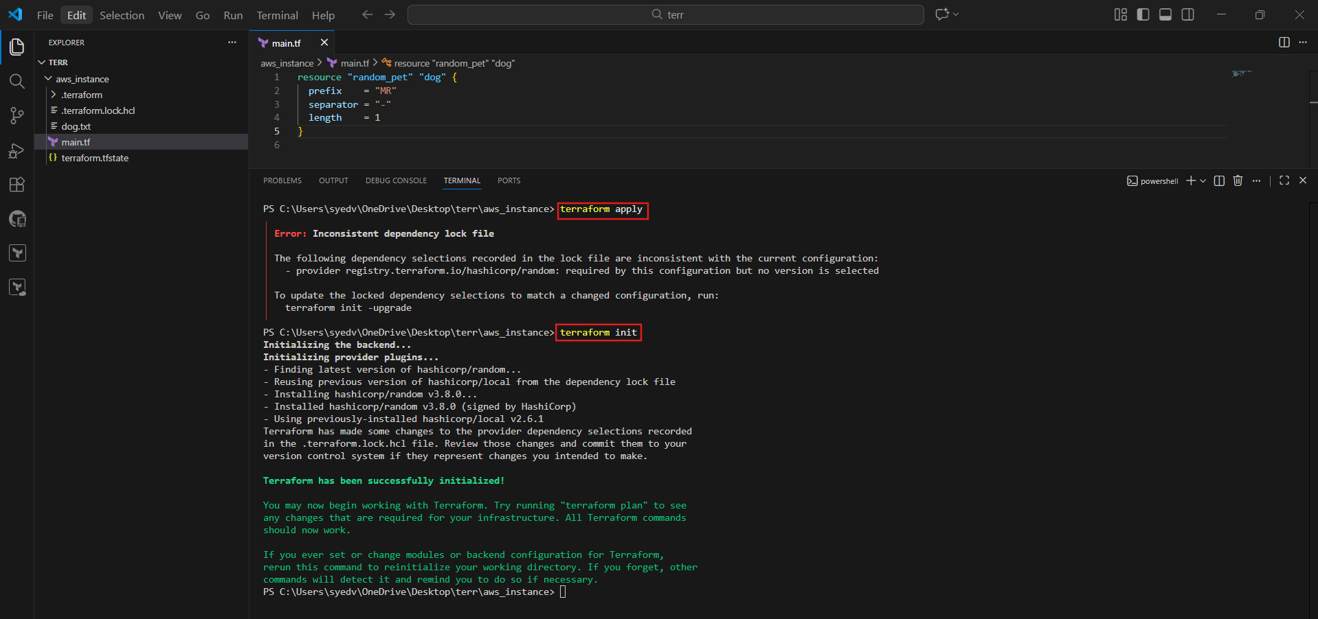
Run:
terraform plan
- Terraform refreshes the state.
- Output shows no changes.
Infrastructure matches the configuration

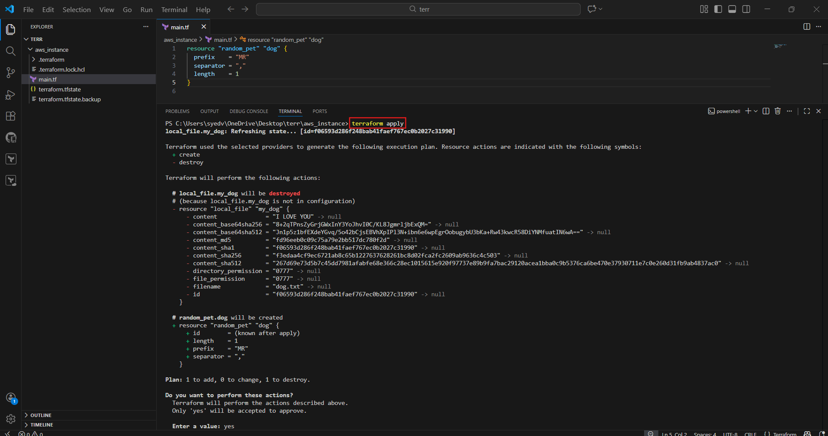

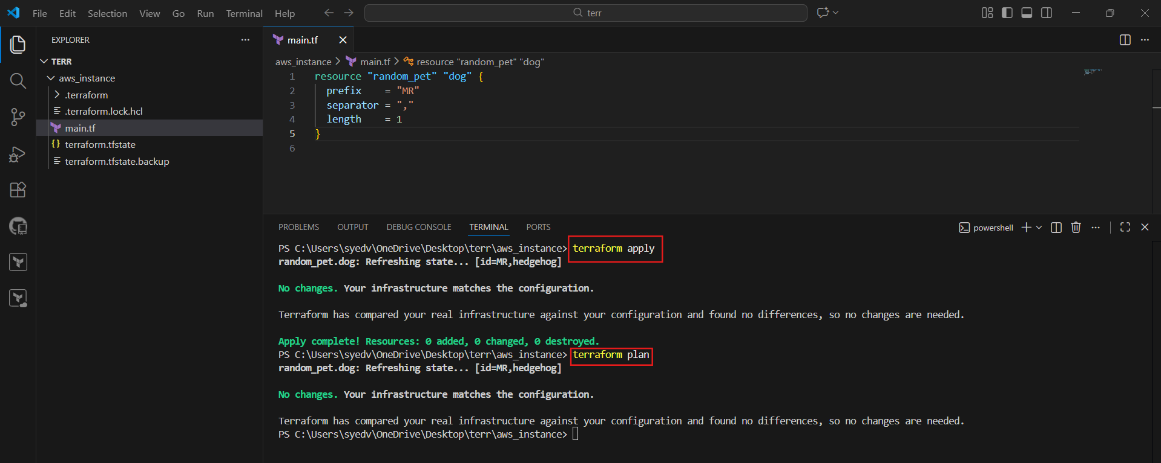
- Open terraform.tfstate in VS Code
- View stored resource details
- It contains resource ID, attributes, and provider info
- This file tracks current infrastructure state

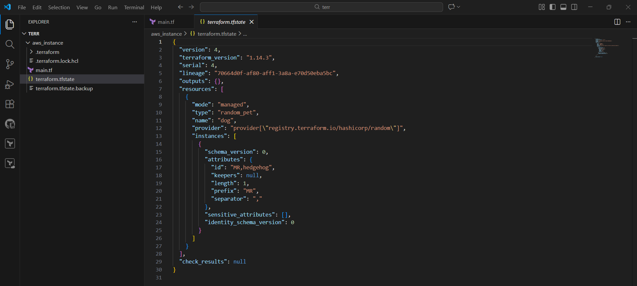
- Modify main.tf to use local_file resource again.
- Define filename and content.
- Save the file.

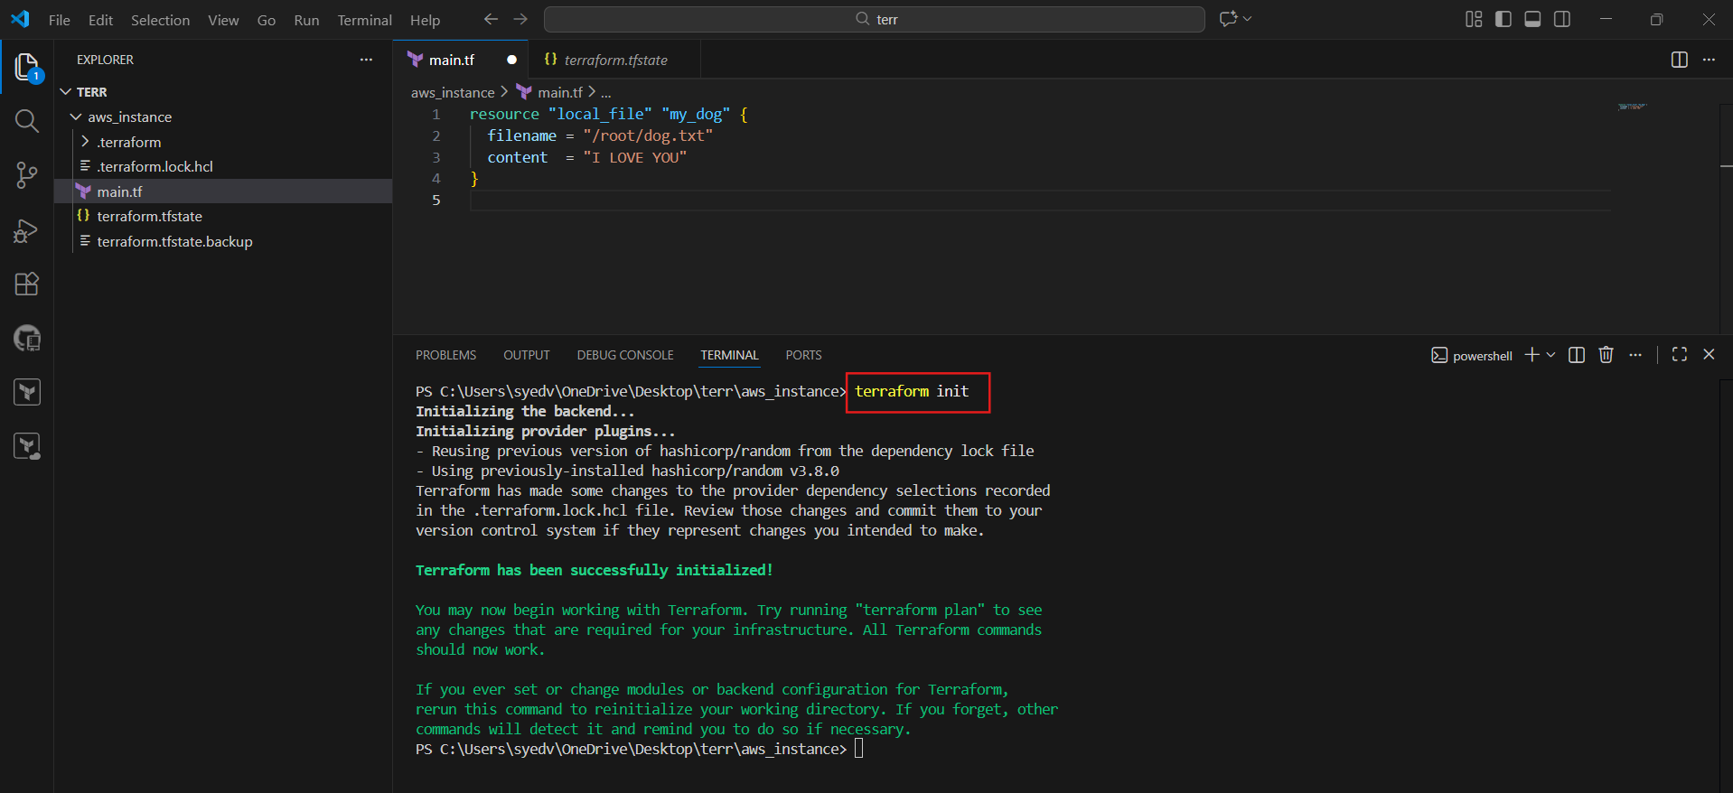
Run:
terraform init
- Terraform reuses existing providers.
- Initialization completes successfully

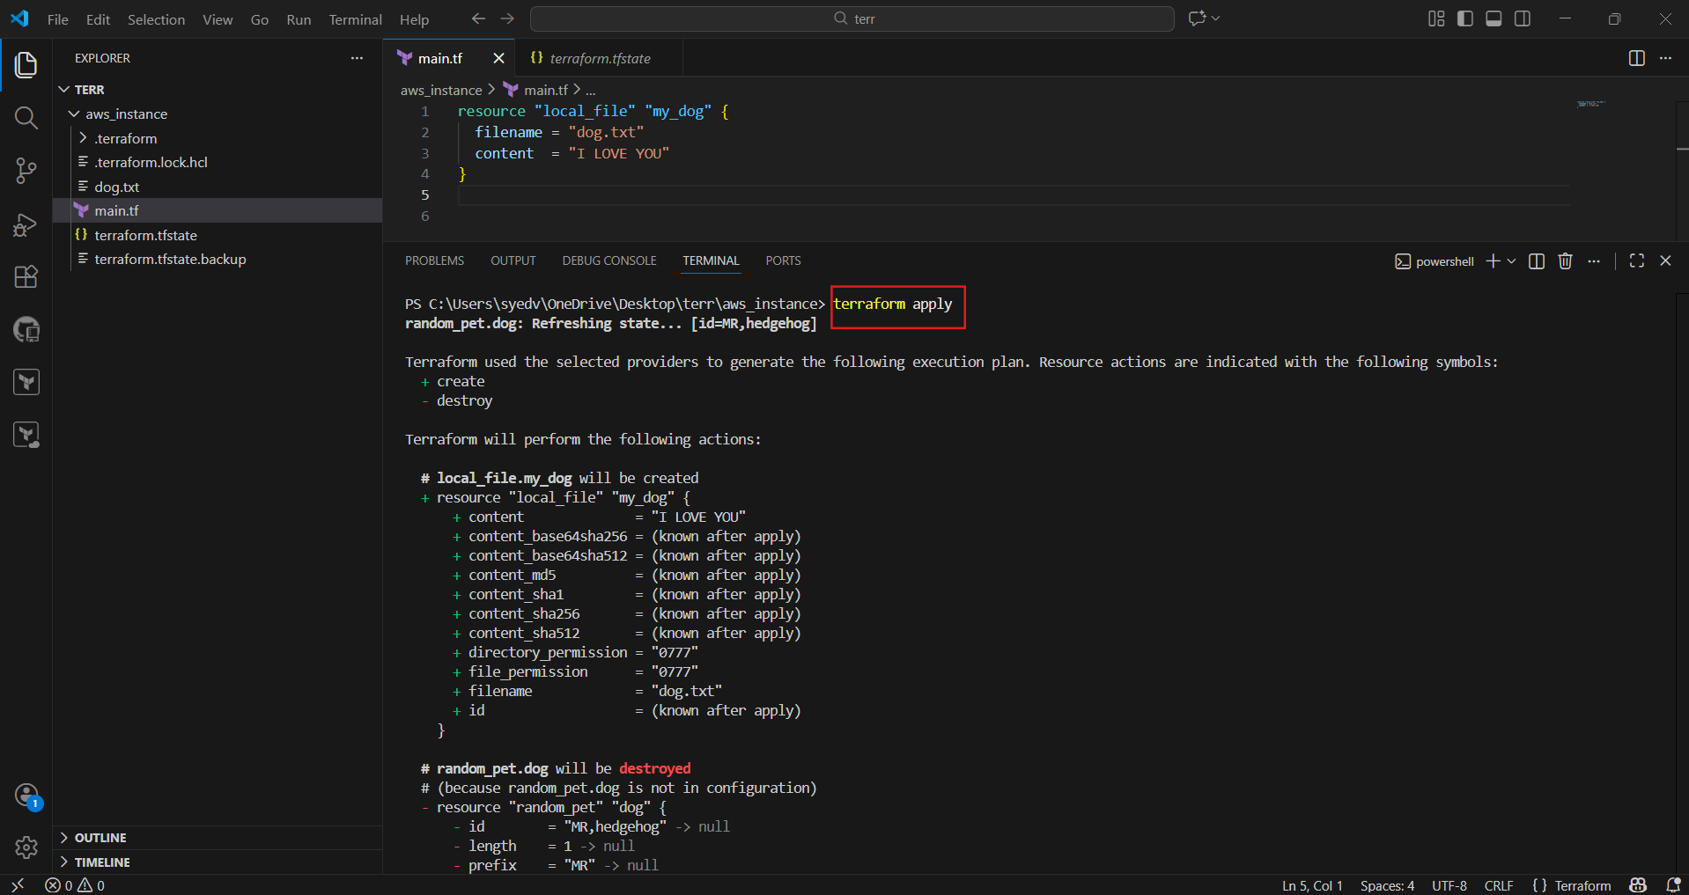
- Run terraform apply
- Review the plan
- Type yes to confirm
- Terraform applies changes and updates the state file
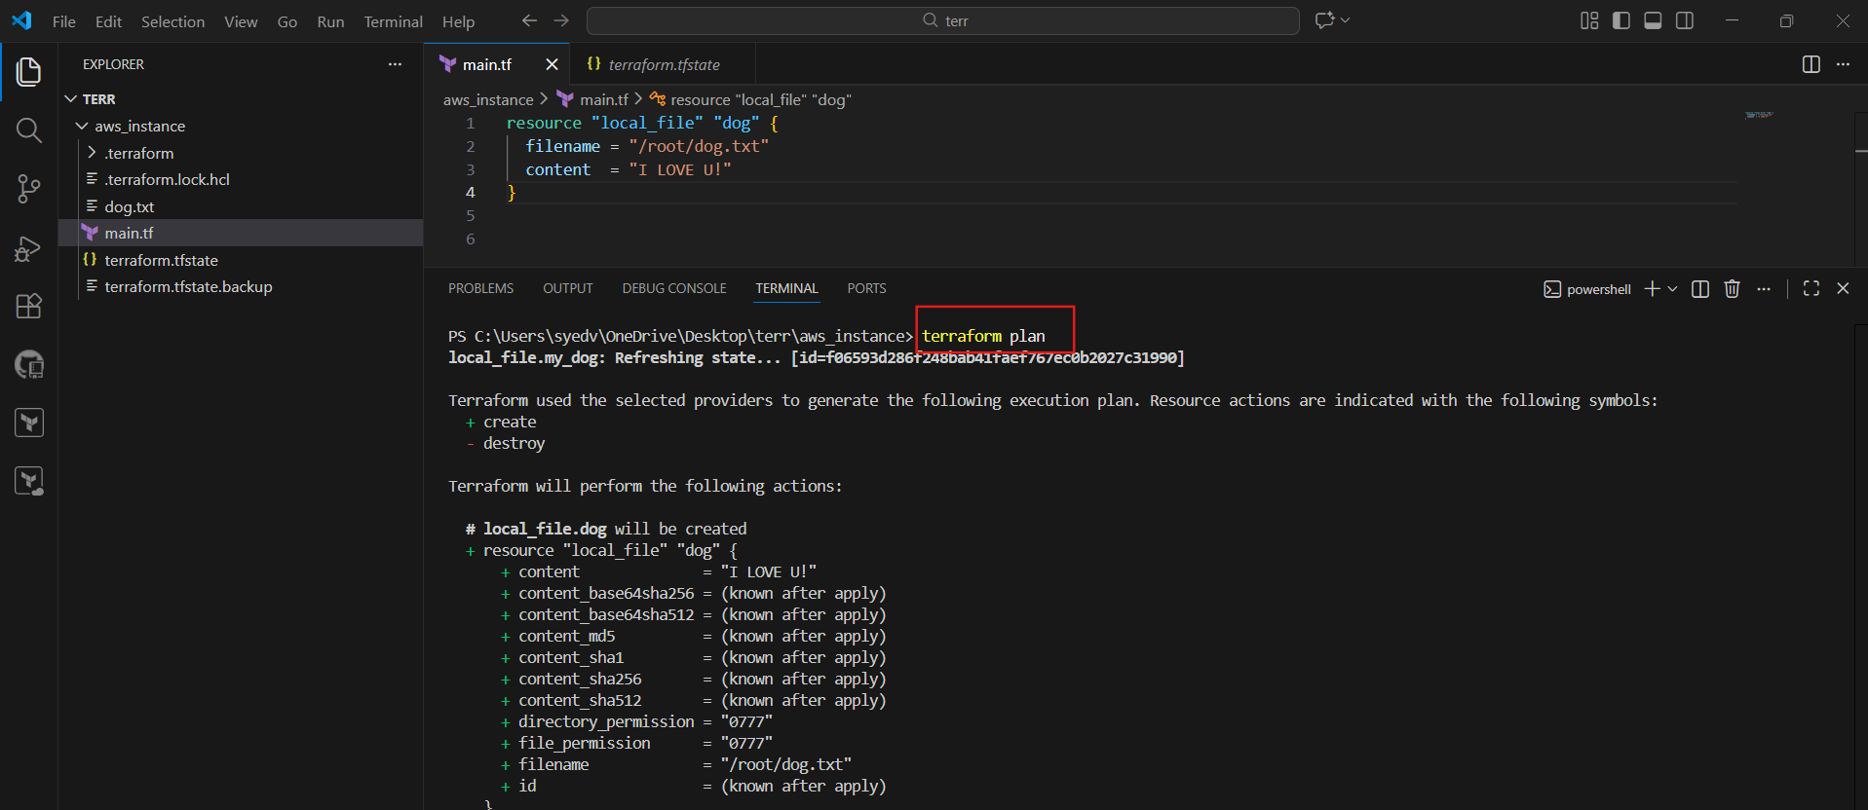
- Open main.tf with local_file resource
- Run terraform destroy
- Terraform refreshes state
- Shows destroy plan
- Asks for confirmation before deleting resources

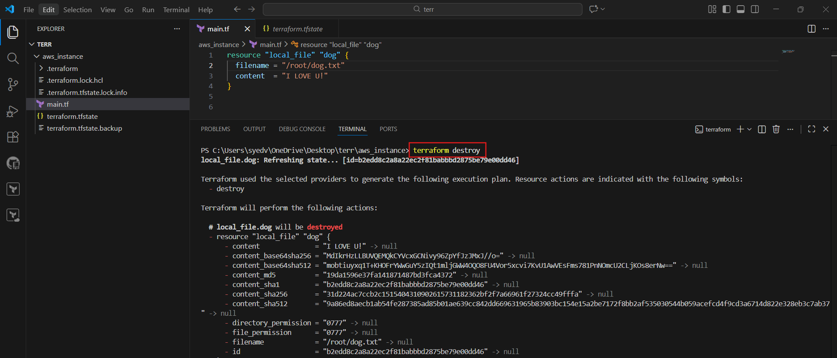
- Open main.tf in VS Code inside the terraform basic folder
- Modify the resource as below:
- Resource type: local_file
- Resource name: my_dog
- Filename: dog.txt
- Content: I LOVE U DOG
- Save the file
- Run in terminal:
terraform init
Terraform initializes backend and providers
- Then run:
terraform plan
Terraform shows a new local_file resource will be created

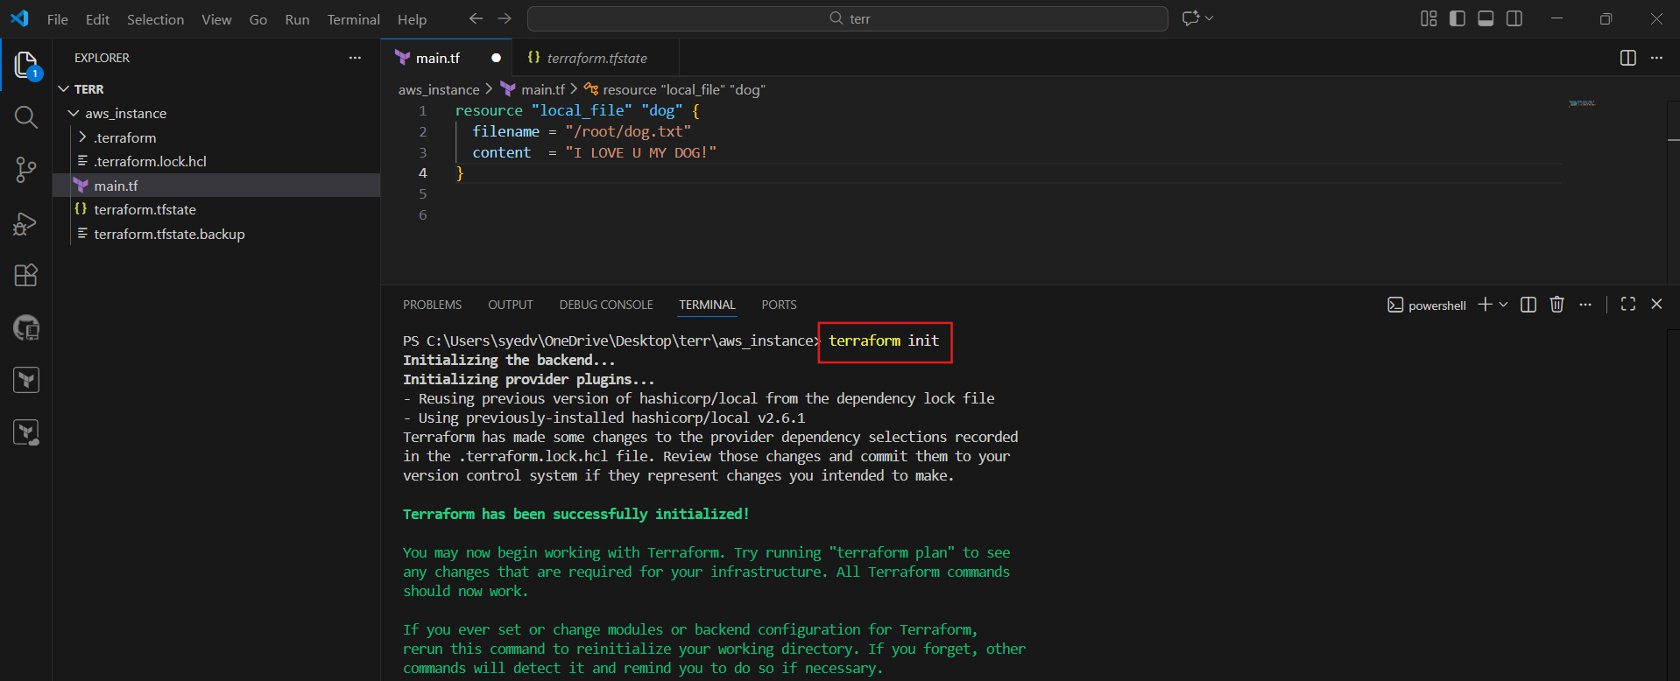
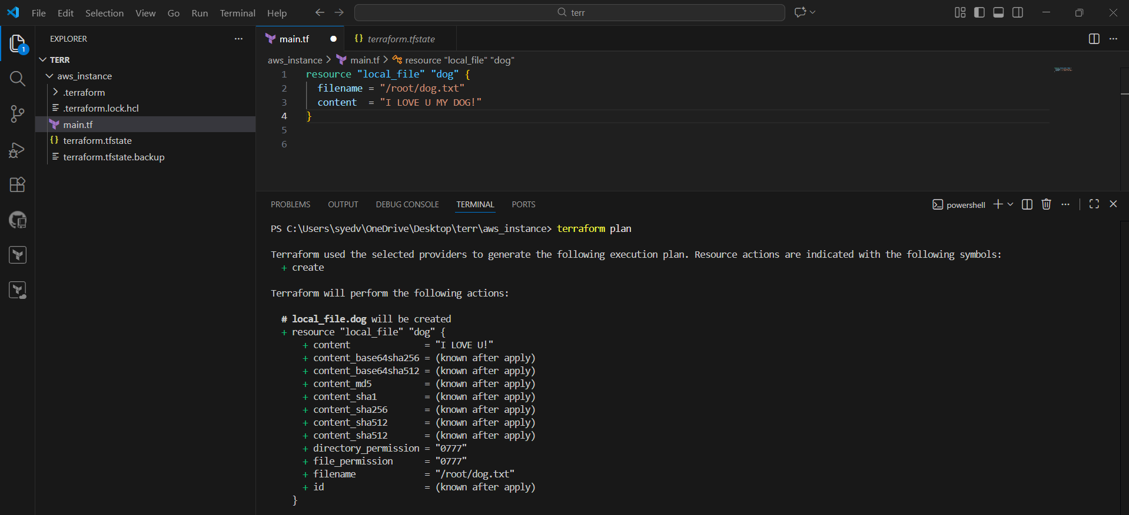
- Run terraform apply
- Review the execution plan
- Type yes to confirm
- Terraform creates dog.txt
- Apply completes successfully

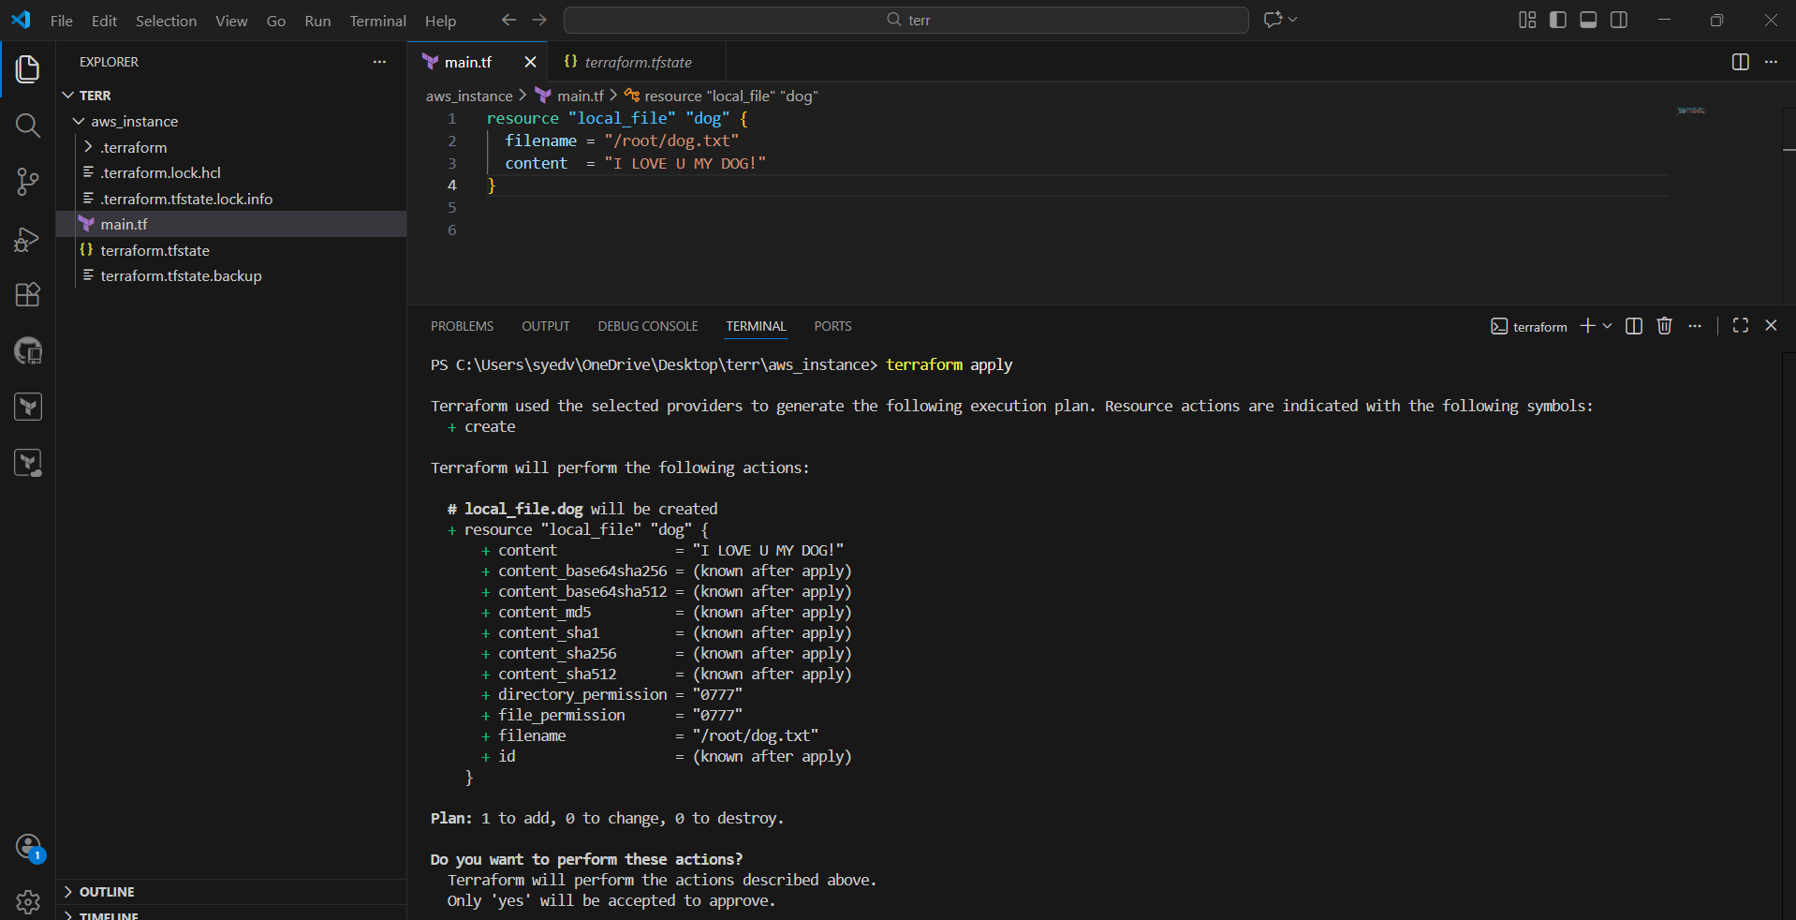
- In VS Code Explorer, find dog.txt
- Open dog.txt
- Verify the content: My pet name is Bruno
- This confirms Terraform created the file successfully

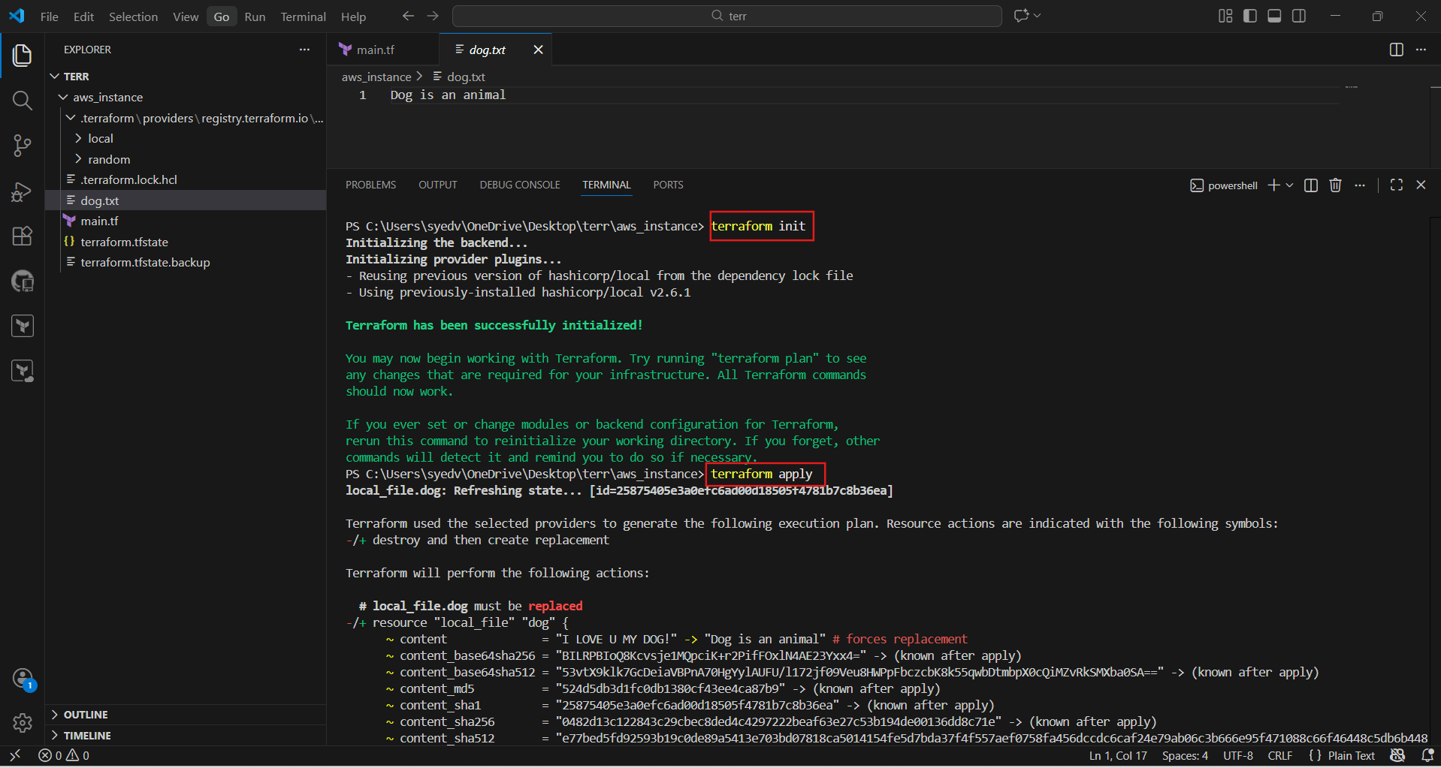

- Integrate Terraform Template in Jenkins
- Open GitHub → New Repository
- Enter repository name: terraform
- Set visibility to Public
- Enable Add README
- Click Create Repository

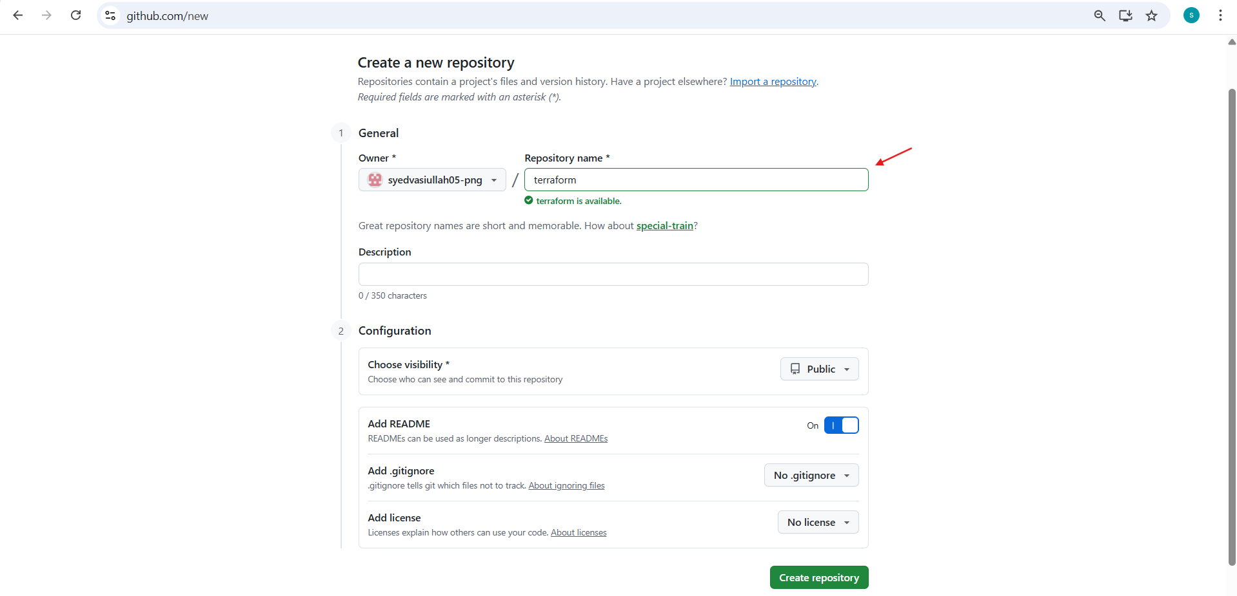
Open the new terraform repository
Create or edit main.tf
Add Terraform configuration
- Define required providers
- Use local file resource
- Set filename and content
Commit changes to the main branch

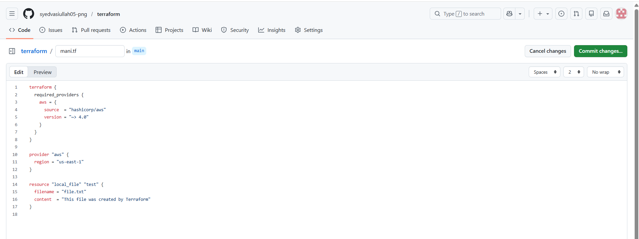
- commit the changes
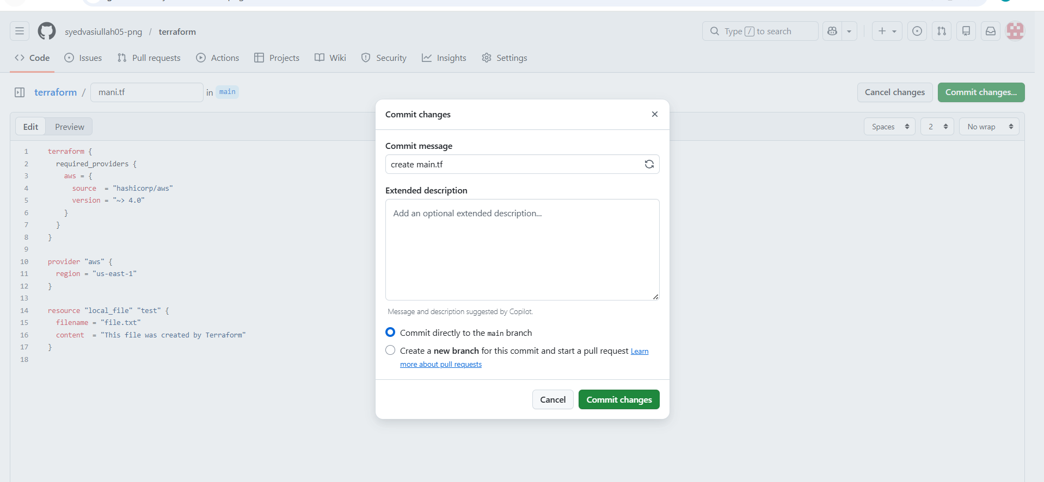
- Log in to Jenkins EC2 instance
- Add Hashi Corp repository
- Install Terraform using yum
- Terraform is installed successfully
- Verify installation without errors
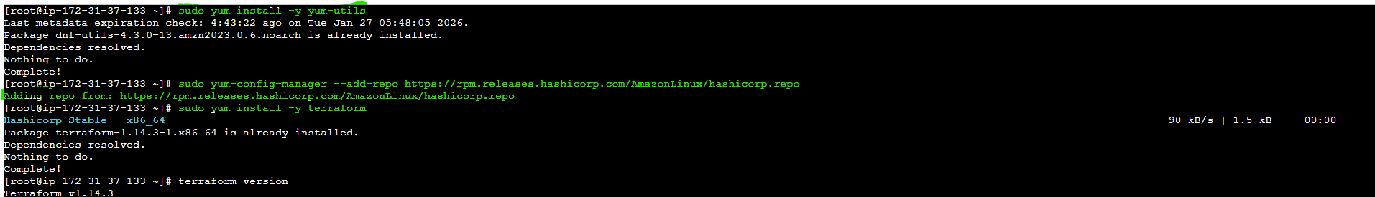
Check the terraform version
Terraform -v
- Run:
- terraform -v
- Terraform version is displayed.
- Confirms Terraform is successfully installed on Jenkins server.

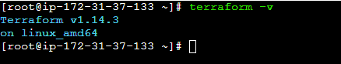
- Open Jenkins dashboard.
- Click New Item.
- Enter job name: terraform-pipeline.
- Select Pipeline as job type.
- Click OK.

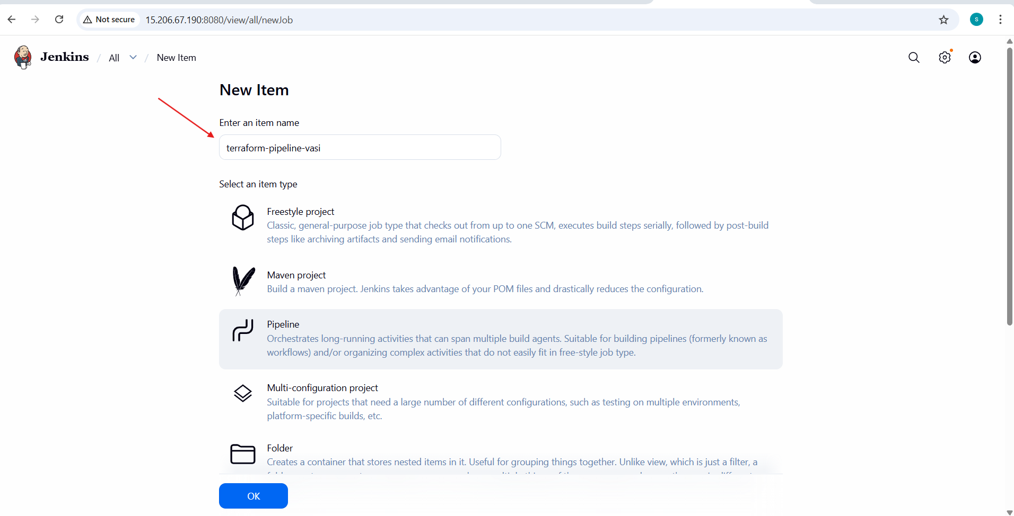
- In Pipeline configuration, select Pipeline script.
- Add stages:
  - Clone GitHub repository
  - Terraform Init
  - Terraform Validate
  - Terraform Plan
- Use GitHub repository URL in clone stage.

- Add Terraform Apply stage with auto-approve
- Add post actions
  - Success message on pipeline success
  - Failure message on pipeline failure
- Save the pipeline configuration

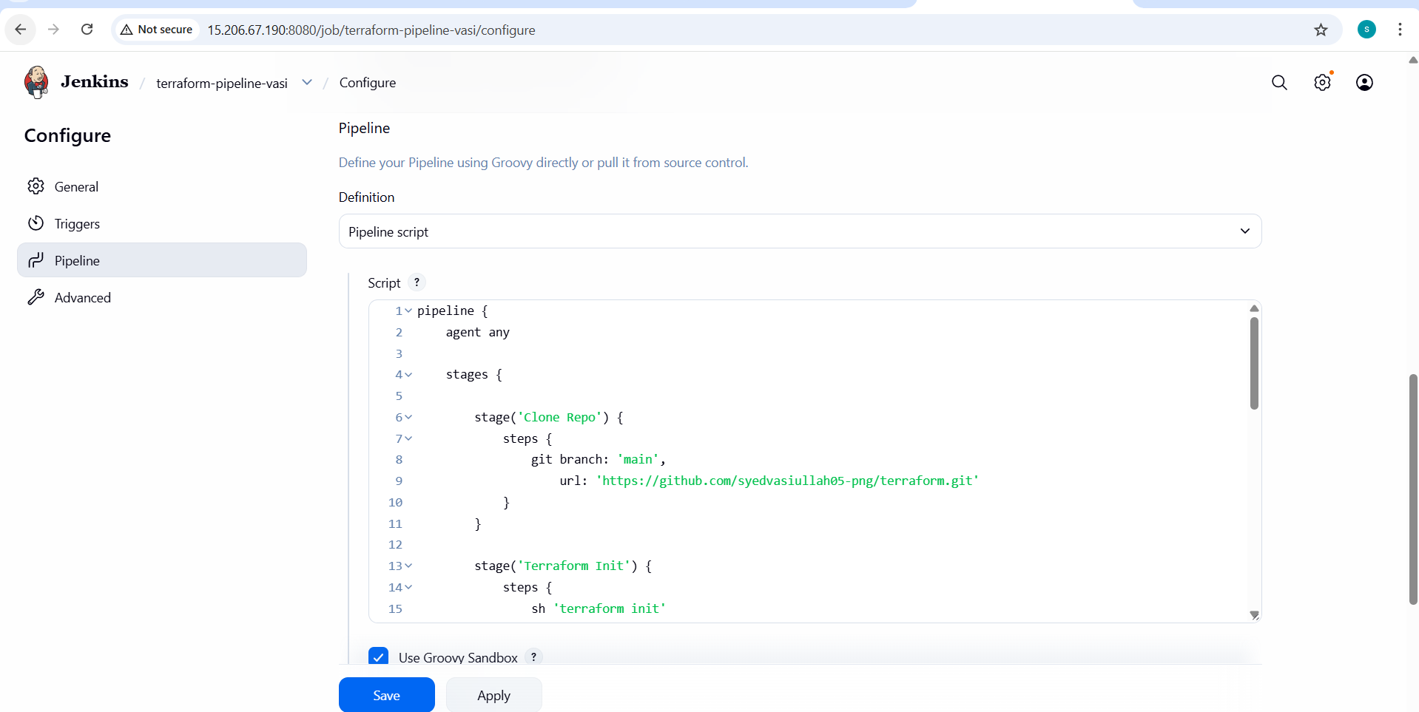
- Trigger the pipeline build
- Jenkins runs stages in order:
Clone Repo → Terraform Init → Validate → Plan → Apply
- All stages complete successfully (green status)

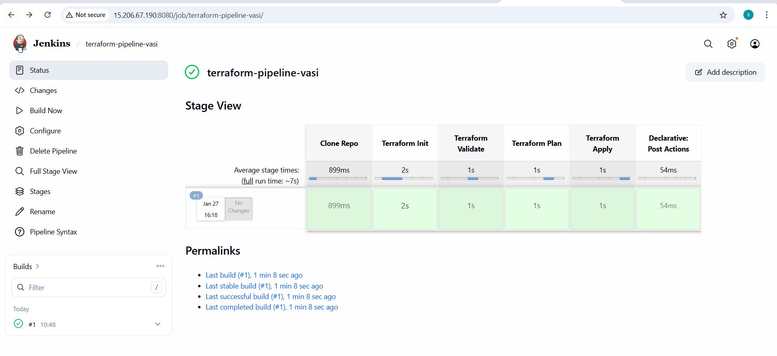
- Log in to Jenkins server
- Go to workspace:
/var/lib/jenkins/workspace/terraform-pipeline
- Run ls to list files
- Terraform code, state file, and output files are present.

